Table of Contents

Abstract i

1. Introduction i

1. Problem Statement ii

2. Problem Solution for the Proposed System iii

3. Related System Analysis/Literature Review iii

4. Advantages/Benefits of Proposed System iv

5. Project Scope iv

6. Modules v

Module 1: User Sign-up/Login: v

Module 2: Category Module: v

Module 3: Cap Module: v

Module 4: Jeans Module: v

Module 5: Shirt Module: vi

Module 6: Trouser Module: vi

Module 7: Watch Module: vi

Module 8: Store Module: vi

Module 9: Order Module: vi

Module 10: Delivery Module: vii

Module 11: Payment Module: vii

7. System Limitations/Constraints vii

8. Software Process and Design Methodology viii

9. Tools and Technologies viii

10. Project Stakeholders and Roles ix

11. Team Members Individual Tasks/Work Division ix

12. Data Gathering Approach x

13. Mockups xi

14. Conclusion xvi

15. References xvi

16. Plagiarism Report xvii

17. ERD xvii

18. Normalization on Tables xviii

19. Database Schema xxii

20. DDL xxiv

21. Mongo xxxix

21.1 Customer: { xxxix

21.2 Cart: xl

21.3 Delivery: xl

21.4 Payment xl

21.5 Receipt: xl

21.6 Products: xli

22. Queries xli

22.1.1 SQL Queries xli

22.1.2 Mondo Queries xliv

**Project Category:**

**(**A Desktop Application/Information System, Web Application/Web Application based Information System)

# Abstract

The proposed project **“Online Shopping Mart”** is a DBMS system that permits a customer to submit orders for items in an easier and more convenient way. The proposed system has a shop that will allow customers to buy and view products/wares and to find specific type of merchandise. The system provides description and price to the items that are kept for sale. The proposed system also provides various categories like clothes, shoes and so on to help the customers in easy searching of the desired product. The system also provides a shopping cart for holding items selected for purchase. The proposed system has a secure online transaction system that allows customers to purchase goods safely using their credit cards, and data security system to ensure that all data is transmitted between various systems. The proposed project is a database program, and it contains all the relevant information regarding the customer management, the store inventory, orders and payments. This system also maintains the customer details, to provide the valuable reports regarding invoice, bill information therefore increasing the efficiency and effectiveness of the system, which makes it smarter than the existing traditional store system.

# Introduction

In the 21st century, such a great variety of things exist on the internet. We can do almost everything on the internet, e.g. studying, buying food and other stuff. As the Modern age is shifting everything to Online, so we decided to provide an Online Shopping Store. Nowadays, most of the purchasing of the items that are needed for the daily basis can be done through online mode. People without wasting much energy in going to the shops to buy the shopping items that are required can purchase it through the shopping websites. **Online Shopping System** is the application that allows the users to shop online. Through **Online Shopping** the Customers would not need to go outside their house and go to different brands to look for their desirable products. The system will provide the clothes of all Brands with just One Click.

This Project **“Online Shopping Store”** is a platform where customers can view and order different types of products to deliver at their doorstep by adding required information. Then they can add the selected item into their cart and upon verification of payment the product will be shipped to Customer. The project is designed to facilitate the database admin, to automate operations of keeping records and store them in the form of large and user-friendly database. Further, the system facilitates easy access to the personal

# Problem Statement

There are a lot of websites on internet whereby it offer a variety of product and services to consumers. Moreover, the online systems also provide some of the services which is paying bill online, booking a transport ticket etc. However, there are several reasons that hinder customers to get involved in online shopping. Some people are not willing to take part in online shopping due to the valid reason that there are worried about the qualities of the product in online are not durable. Another important problem faced while shopping online is the delivery date and logistics. Sometimes, delivery executives deliver the product to the wrong address. As many people shop online these days, cyber criminals come up with innovative techniques to hack e-commerce websites and steal money from online shoppers. E-commerce sites will have important customer data like names, phone numbers, address, and bank details. If these details fall in the hand of fraudsters they can be misused.

# Problem Solution for the Proposed System

The proposed system will not only guarantee the quality of the product but will also help the users to track their orders, help them assess their product properly and give them all the information they need to feel comfortable purchasing your product. Moreover, the proposed system will ensure the security of important data.

# Related System Analysis/Literature Review

**4.1 Daraz PK**

**Daraz** is an online store that provides branded products for men and women across clothing, footwear, apparel, jewelry and accessories. Daraz started in 2012 as an online fashion retailer and evolved into a general marketplace for brands selling items ranging from electronics to home appliances to fashion. The foremost motive is **to provide the exact product you love**; at your doorstep regardless of time, place or geographical location, while understanding the precise needs of each customer.

Table 1: Related System Analysis with Targeted Project Solution.

|  |  |  |
| --- | --- | --- |
| **Application Name** | **Weakness** | **Proposed Project Solution** |
| * **Daraz PK** | * **Daraz PK** has a consumer rating of **2.32 stars** indicating that most customers are generally dissatisfied with their purchases. Consumers complaining about Daraz PK most frequently mention customer service and low quality problems. Users receive faulty and damaged goods. Also daraz pk takes too long to deliver the ordered products. | * Users will be able to track their orders. Moreover, the quality of the products is guaranteed. |

# 

# Advantages/Benefits of Proposed System

* The proposed system will allow saving all the records in the database.
* The proposed system is fast, secure, easy to use and reliable.
* The system provides hassle free finance collection processes.
* The proposed system reduces the staff requirements.
* The system will help in saving time, as it is easy to access what you want in just one click.

# Project Scope

This system is basically focused on consumer end to facilitate user as much as possible. Moreover, The Online Shopping Mart covers the following perspectives:

* Customers will be able to shop their apparels without leaving their homes.
* Customers can sign-up/login and view their Profile data, place/cancel orders, view products, view their shopping carts etc.
* A contactless payment method is introduced by use of credit/debit card to facilitate Customers.
* Products will be delivered to customer’s doorstep and customer will be able to track its product’s delivery status.

# Modules

## Module 1: User Sign-up/Login:

**Features:**

* In this module, all features of user’s registration, logging in of existing users will be implemented.
* A new user will be able to sign-up and then by filling in some credentials in the registration form.
* User will be asked for CNIC and password when he registers for the first time.
* User will be able to access the dashboard by logging in if he is already registered.

## Module 2: Category Module:

**Features:**

* This module divides the available products into 6 categories.
* The user will be able to select from these categories and view products.

## Module 3: Cap Module:

**Features:**

* This module contains total stock of all the available products of such type with their colors, brands, prices and size specifications.

## Module 4: Jeans Module:

**Features:**

* This module contains total stock of all the available products of such type with their colors, brands, prices and size specifications.

## Module 5: Shirt Module:

**Features:**

* This module contains total stock of all the available products of such type with their colors, brands, prices and size specifications.

## Module 6: Trouser Module:

**Features:**

* This module contains total stock of all the available products of such type with their colors, brands, prices and size specifications.

## Module 7: Watch Module:

**Features:**

* This module contains total stock of all the available products of such type with their colors, brands, prices and size specifications.

## Module 8: Store Module:

**Features:**

* Store module contains the list of stores registered on Online Shopping with their respective product categories and stock inventory details.

## Module 9: Order Module:

**Features:**

* This module contains all the orders placed by various customers, order_ID is primary key while CNIC and customer_ID are foreign keys.

## Module 10: Delivery Module:

**Features:**

* This module contains the delivery record of the specific person who is buying something and his CNIC will be the key to reach our goal in this case

## Module 11: Payment Module:

**Features:**

* This module consists of customer payment method, total amount, CNIC, currency and Credit-card.

# System Limitations/Constraints

* The website will be available in English language only.
* If the user's internet connection is weak, he or she would be unable to access and use the Online Shopping System's services.
* If a user does not know the Online Shopping System's website address, the system is inaccessible.
* The system does not have any gender wise category of products.
* The accessories category has a vast number of products with different brands and prices which is sometimes not accurately reflected.
* Insertion in product size table is constrained by size attribute i.e., small, medium, large and full only.

# Software Process and Design Methodology

We will use Incremental process method for our app to implement more features and improve the existing ones. Moreover, we have used UML for Design Methodology.

# Tools and Technologies

To build our system, we will use IntelliJ (Java) on the front-end and handle back-end with Sql Developer. Database management will be done by MongoDB.

Table 2: Tools and Technologies for the Targeted Project.

|  |  |  |  |
| --- | --- | --- | --- |
| **Tools**  **And**  **Technologies** | **Tools** | **Version** | **Rationale** |
| Mongo db compass | 1.29 | Database |
| SQL Developer | 20.4.0 | Database |
| SQL Developer Data Modeler | 21.1.0 | Graphical Tool |
| MS Word | 2015 | Documentation |
| IntelliJ (Java) | 21.3 | IDE |
| **Technology** | **Version** | **Rationale** |
| Java | 6.0 | Programming Language |
| SQL | 20.4.0 | Query Language |
| Mongo db | 5.0.4 | Rationale Query Language |

# Project Stakeholders and Roles

Table 3: Project Stakeholders for the Targeted Project.

|  |  |
| --- | --- |
| **Project Sponsor** | **COMSATS University Islamabad** |
| **Stakeholder** | * Student's names  1. *Zahra Saeed* 2. *Zeeshan Fareed* 3. *Nimra Zaigham*  * Project Supervisor Name: *Sir Basit Raza* * Final Year Project Committee: *Evaluation of project.* |

# Team Members Individual Tasks/Work Division

Table 4: Team Member Work Division the Targeted Project.

|  |  |  |
| --- | --- | --- |
| **Student Name** | **Student Registration Number** | **Responsibility/ Modules** |
| * **Zahra Saeed** | * **SP20-BSE-100** | * **Module 1** * **Module 2** * **Module 3** * **Module 4** |
| * **Nimra Zaigham** | * **SP20-BSE-077** | * **Module 5** * **Module 6** * **Module 7** |
| * **Zeeshan Fareed** | * **SP20-BSE-101** | * **Module 8** * **Module 9** * **Module 10** * **Module 11** |

# Data Gathering Approach

The main data gathering source would be the internet. Although some questionnaires; were also done for acquiring data. Once the application is complete, we will use data collected from the users to improve quality and working of the Online Shopping Mart.**.**

# Mockups

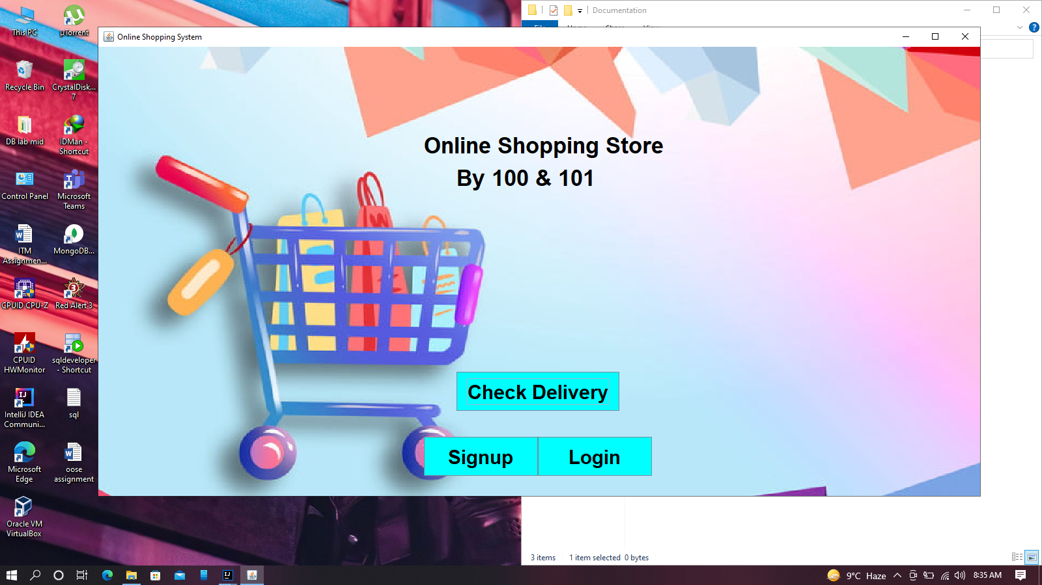

**Figure 3: Mockup-01 -Design Mockup for Sign-Up/Login and Check Deliver.**

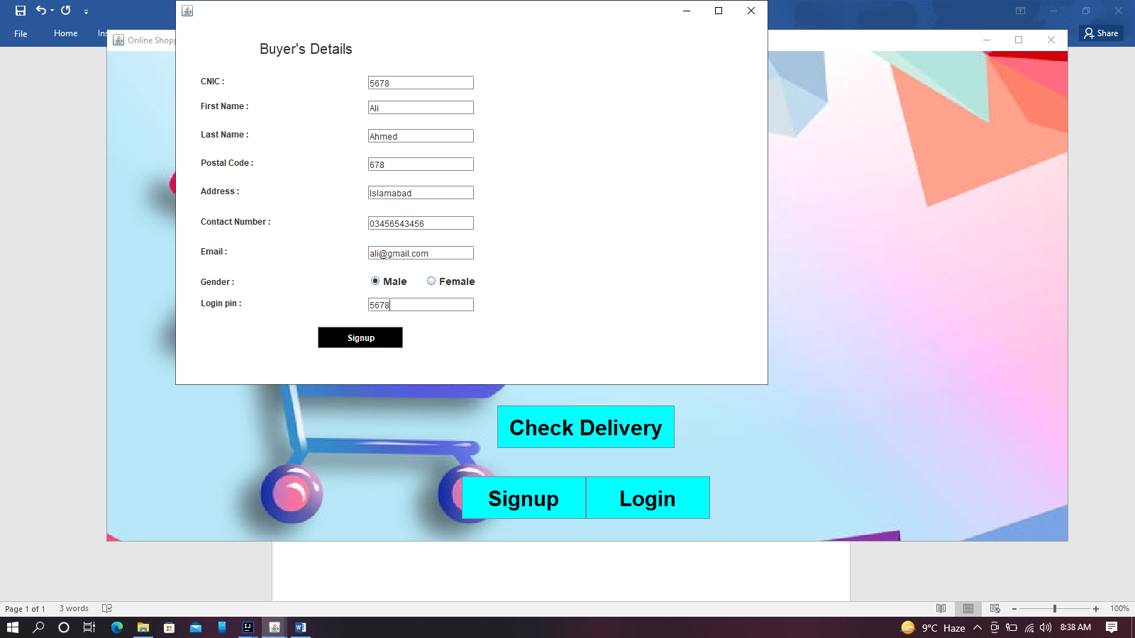

**Figure 3: Mockup-02 -Design Mockup for Sign-Up Page.**

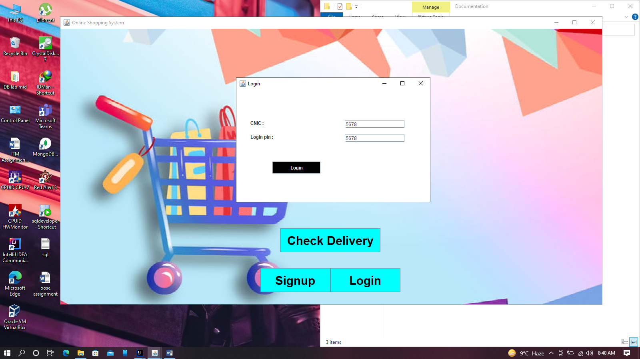

**Figure 3: Mockup-3 -Design Mockup for Login Page.**

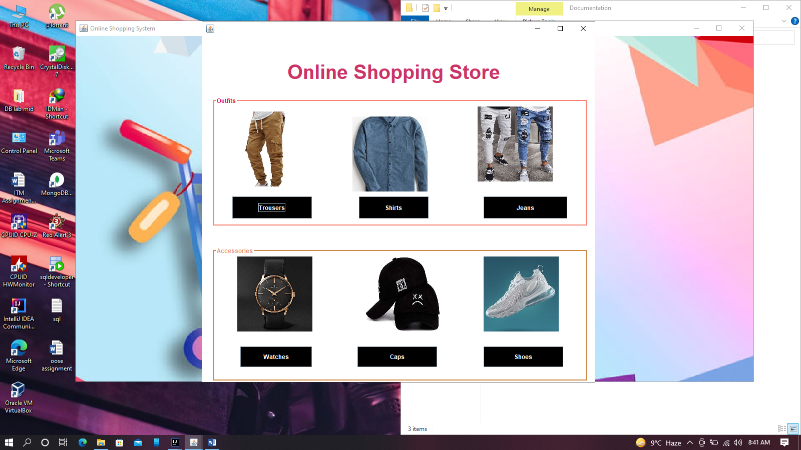

**Figure 4: Mockup-4 -Design Mockup for Product Categories.**

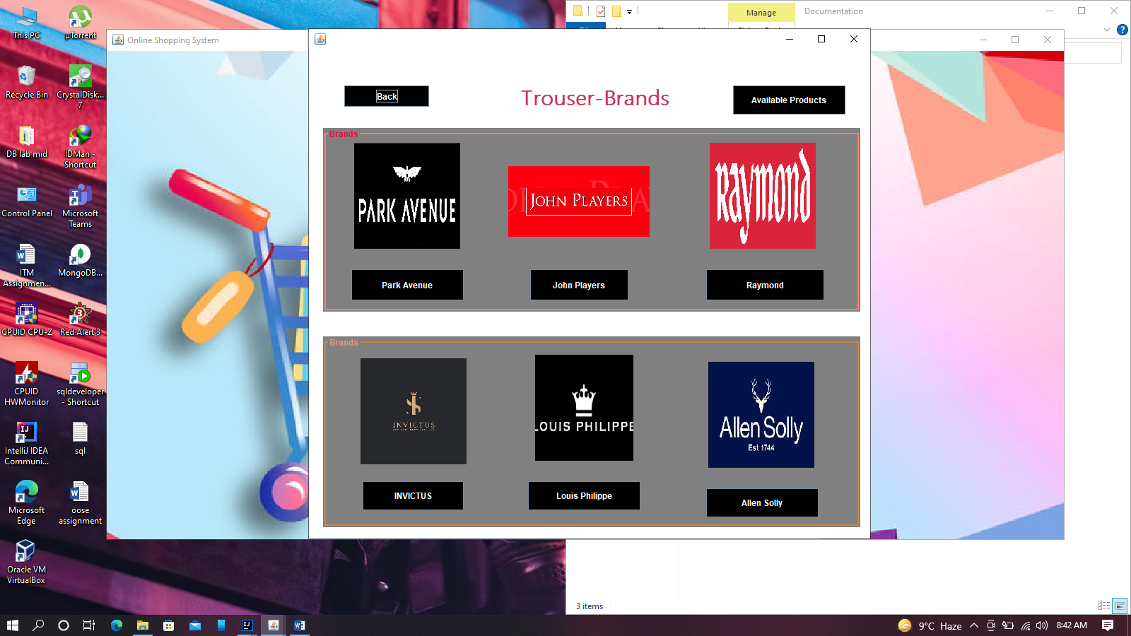

**Figure 5: Mockup-5 -Design Mockup for Available brands for a product.**

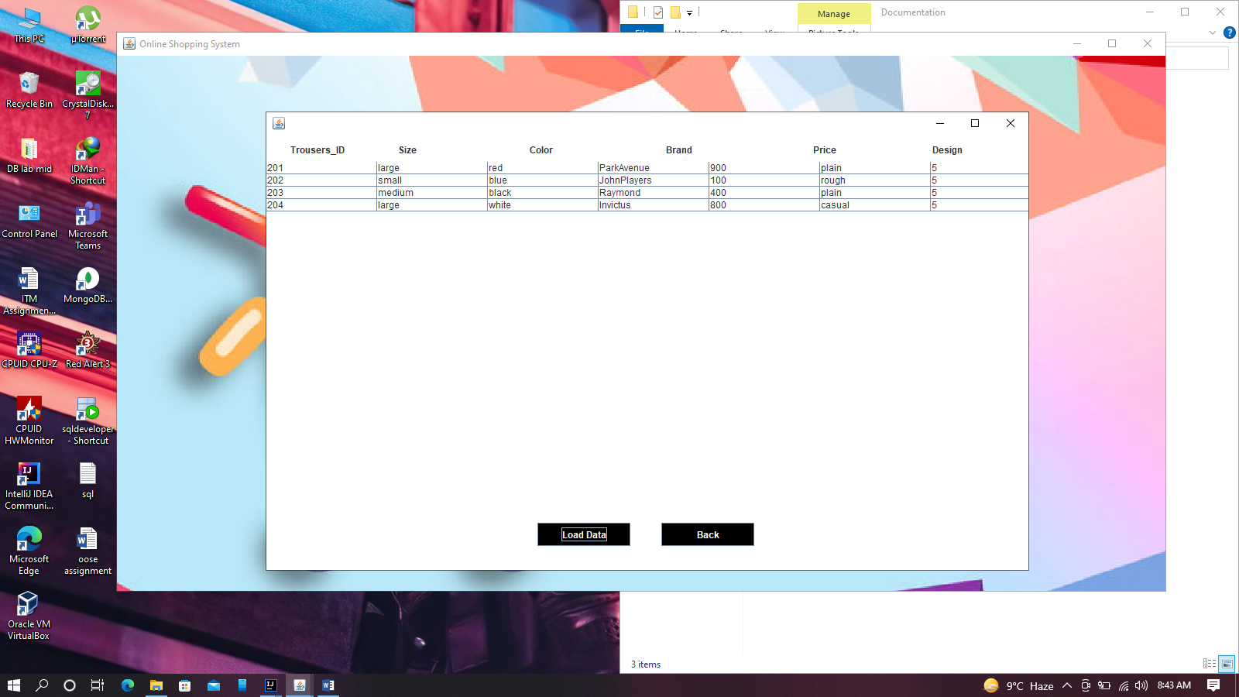

**Figure 6: Mockup-6 -Design Mockup for All available products in a category.**

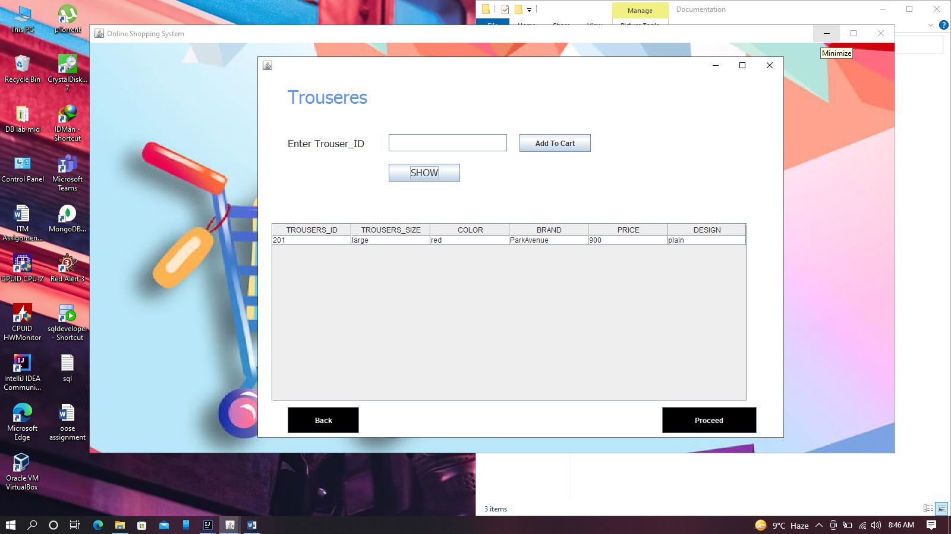

**Figure 7: Mockup-7 -Design Mockup for Available products of a Brand with option to insert desired product in cart:**

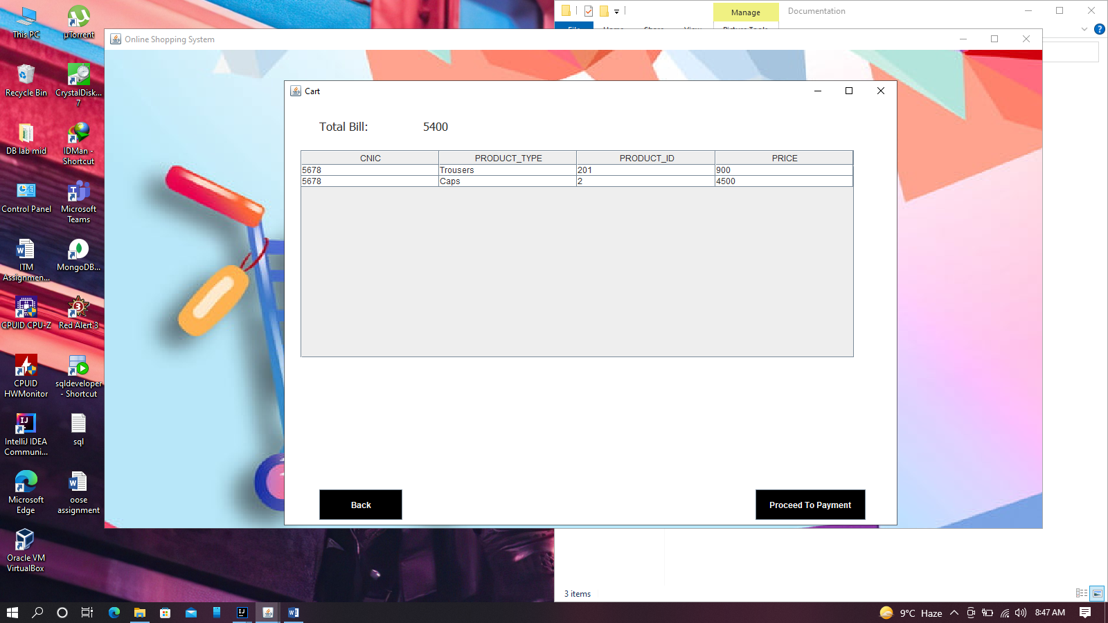

**Figure 8: Mockup-8 -Design Mockup for Cart:**

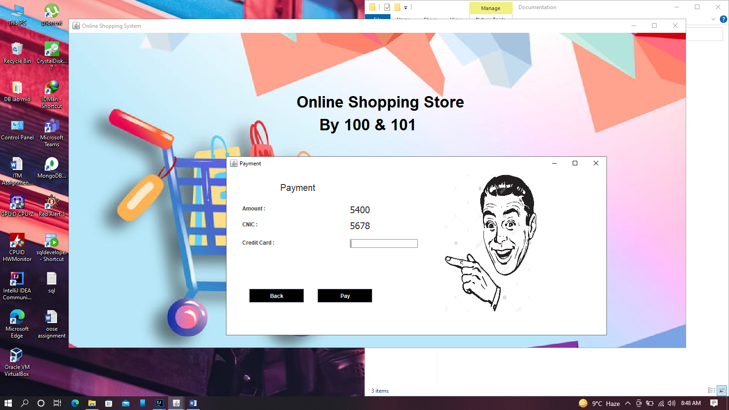

**Figure 9: Mockup-9 -Design Mockup for Payment Panel with Credit Card as Payment method:**

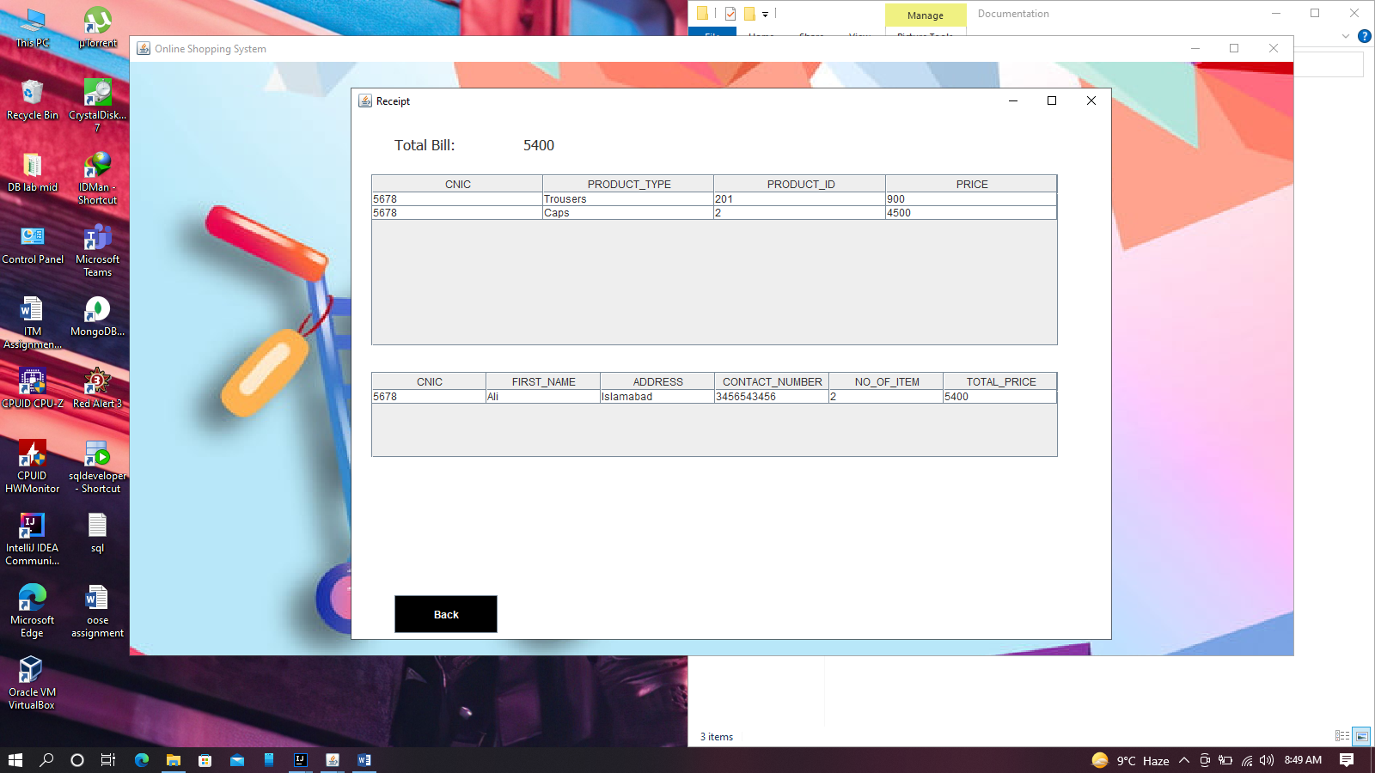

**Figure 10: Mockup-10 -Design Mockup for Receipt:**

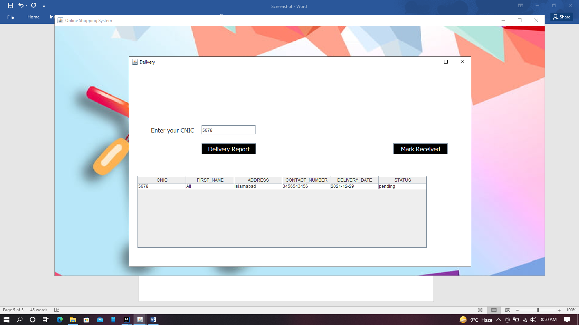

**Figure 11: Mockup-11 -Design Mockup for Receipt Delivery Report:**

# Conclusion

The objective of this project was to build a database for maintaining the details of all the customers, stores and delivery etc. The system developed will able to meet all the basic requirements. The management of the records (both customers and products) will be also benefited by the proposed system, as it will automate the whole procedure, which will reduce the workload. The important thing is that the system would be flexible enough for future modifications. The system has been factored into different modules to make system adapt to the further changes. Every effort has been made to cover all user requirements and make it user friendly.

# References

* (Project Report on Online Shopping System)
* (Online Shopping System)

# Plagiarism Report

# ERD

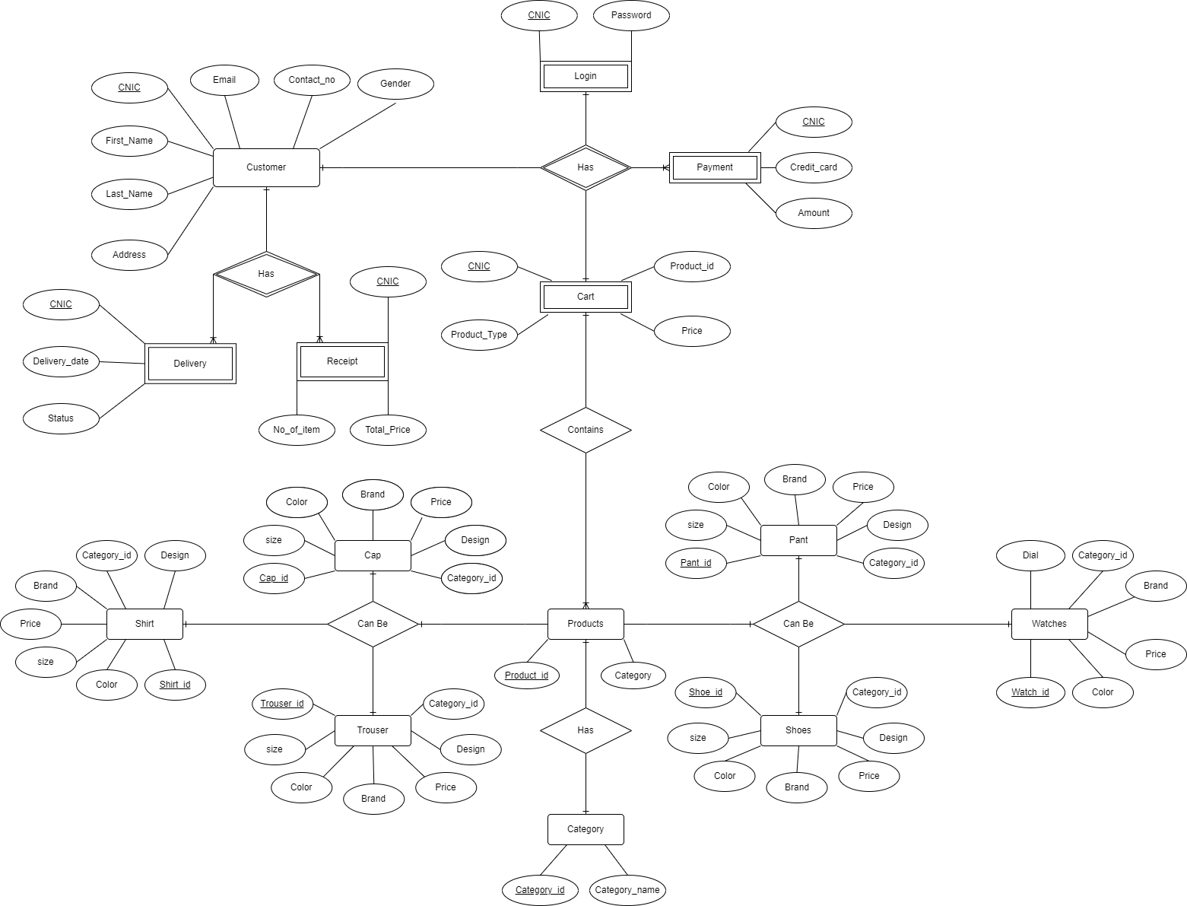

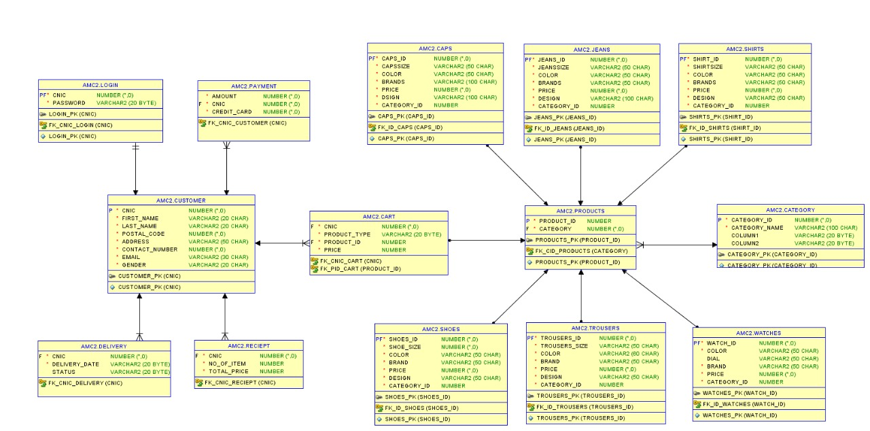

# Normalization on Tables

**Customer**

|  |  |  |  |  |  |  |  |  |  |  |  |  |  |  |  |  |
| --- | --- | --- | --- | --- | --- | --- | --- | --- | --- | --- | --- | --- | --- | --- | --- | --- |
| Cnic[PK] | Name | Password | Postal Code | Address | Contact No | Email | Gender | Credit  Card | Total Payment | Items ID | Category | Brand | Size | Design | Price | Delivery |
| 8080 | Umair Ali | 1234 | 10250 | Mirpur AJK | 03456787654 | [umi@gmail.com](mailto:umi@gmail.com) | Male | 5674 | 2500 | 1 | Cap | Puma | Small | Formal | 2500 | 27-12-2021 |
| 8081 | Ahsan Zia | 7896 | 45600 | Islamabad | 03423457896 | [A324@gmail.com](mailto:A324@gmail.com) | Male | 7864 | 4500 | 56, 104 | Shoes, shirt | Nike, Everlane | Medium, Small | Sports, Dress | 3000, 1500 | 29-12-2021 |
| 8082 | Umar Rauf | 5637 | 40050 | Lahore | 03458765987 | [umarr@yahoo.com](mailto:umarr@yahoo.com) | Male | 9875 | 4000 | 156 | Jeans | Lee | Large | Tight | 4000 | 01-01-2022 |

We would face update delete anomalies with Items ordered as each customer can order more than one item so it is a multivalued attribute and all respective fields also. So for our table to be in 1NF we will make all entries atomic.

**Customer**

|  |  |  |  |  |  |  |  |  |  |  |  |  |  |  |  |  |
| --- | --- | --- | --- | --- | --- | --- | --- | --- | --- | --- | --- | --- | --- | --- | --- | --- |
| Cnic[PK] | Name | Password | Postal Code | Address | Contact No | Email | Gender | Credit  Card | Total Payment | Items ID | Category | Brand | Size | Design | Price | Delivery |
| 8080 | Umair Ali | 1234 | 10250 | Mirpur AJK | 03456787654 | [umi@gmail.com](mailto:umi@gmail.com) | Male | 5674 | 2500 | 1 | Cap | Puma | Small | Formal | 2500 | 27-12-2021 |
| 8081 | Ahsan Zia | 7896 | 45600 | Islamabad | 03423457896 | [A324@gmail.com](mailto:A324@gmail.com) | Male | 7864 | 4500 | 56 | Shoes | Nike | Medium | Sports | 3000 | 29-12-2021 |
| 8081 | Ahsan Zia | 7896 | 45600 | Islamabad | 03423457896 | [A324@gmail.com](mailto:A324@gmail.com) | Male | 7864 | 4500 | 104 | shirt | Everlane | Small | Dress | 1500 | 29-12-2021 |
| 8082 | Umar Rauf | 5637 | 40050 | Lahore | 03458765987 | umarr@yahoo.com | Male | 9875 | 4000 | 156 | Jeans | Lee | Large | Tight | 4000 | 01-01-2022 |

Now all the entries are atomic, but we have redundant data as Customer Ahsan Zia is repeated twice and any update in one will have data inconsistency in updating data. And also there is partial dependencies in table as password and item purchased depends on cnic of customer only. To fix this and for our table to be in 2NF we would add a table as login to contain cnic and password and cart that contains all the items customer wants to buy.

**Customer**

|  |  |  |  |  |  |  |  |  |
| --- | --- | --- | --- | --- | --- | --- | --- | --- |
| Cnic[PK] | Name | Postal Code | Address | Contact No | Email | Gender | Credit  Card | Total Payment |
| 8080 | Umair Ali | 10250 | Mirpur AJK | 03456787654 | [umi@gmail.com](mailto:umi@gmail.com) | Male | 5674 | 2500 |
| 8081 | Ahsan Zia | 45600 | Islamabad | 03423457896 | [A324@gmail.com](mailto:A324@gmail.com) | Male | 7864 | 4500 |
| 8082 | Umar Rauf | 40050 | Lahore | 03458765987 | [umarr@yahoo.com](mailto:umarr@yahoo.com) | Male | 9875 | 4000 |

**Login**

|  |  |
| --- | --- |
| Cnic[FK] | Password |
| 8080 | 1234 |
| 8081 | 7896 |
| 8082 | 5637 |

**Cart**

|  |  |  |  |  |  |  |  |
| --- | --- | --- | --- | --- | --- | --- | --- |
| Cnic[FK] | Items ID | Category | Brand | Size | Design | Price | Delivery |
| 8080 | 1 | Cap | Puma | Small | Formal | 2500 | 27-12-2021 |
| 8081 | 56 | Shoes | Nike | Medium | Sports | 3000 | 29-12-2021 |
| 8081 | 104 | Shirt | Everlane | Small | Dress | 1500 | 29-12-2021 |
| 8082 | 156 | Jeans | Lee | Large | Tight | 4000 | 01-01-2022 |

For Cart table there is transitive dependency as brand, size, price and design depend on item id and item id depends on category so we will break the cart. Furthermore there is transitive dependency in customer also as customer can use multiple card for multiple payment so total payment depends on credit card number and credit card number depends on Customer so a payment table will also be introduced for 3NF.

**Customer**

|  |  |  |  |  |  |  |
| --- | --- | --- | --- | --- | --- | --- |
| Cnic[PK] | Name | Postal Code | Address | Contact No | Email | Gender |
| 8080 | Umair Ali | 10250 | Mirpur AJK | 03456787654 | [umi@gmail.com](mailto:umi@gmail.com) | Male |
| 8081 | Ahsan Zia | 45600 | Islamabad | 03423457896 | [A324@gmail.com](mailto:A324@gmail.com) | Male |
| 8082 | Umar Rauf | 40050 | Lahore | 03458765987 | [umarr@yahoo.com](mailto:umarr@yahoo.com) | Male |

**Payment**

|  |  |  |
| --- | --- | --- |
| Cnic[FK] | Credit  Card | Total Payment |
| 8080 | 5674 | 2500 |
| 8081 | 7864 | 4500 |
| 8082 | 9875 | 4000 |

**Cart**

|  |  |  |  |
| --- | --- | --- | --- |
| Cnic[FK] | Items ID[FK] | Category | Delivery |
| 8080 | 1 | Cap | 27-12-2021 |
| 8081 | 56 | Shoes | 29-12-2021 |
| 8081 | 104 | shirt | 29-12-2021 |
| 8082 | 156 | Jeans | 01-01-2022 |

**Products**

|  |  |  |  |  |  |  |
| --- | --- | --- | --- | --- | --- | --- |
| Items ID[PK] | Category | Brand | Color | Size | Design | Price |
| 1 | Cap | Puma | Black | Small | Formal | 2500 |
| 56 | Shoes | Nike | Blue | Medium | Sports | 3000 |
| 104 | Shirt | Everlane | Grey | Small | Dress | 1500 |
| 156 | Jeans | Lee | Blue | Large | Tight | 4000 |

After adding few more tables resultant database schema is given next.

# Database Schema

**Customer**

|  |  |  |  |  |  |  |  |
| --- | --- | --- | --- | --- | --- | --- | --- |
| Cnic[PK] | First_Name | Last_Name | Postal Code | Address | Contact No | Email | Gender |
|  |  |  |  |  |  |  |  |
|  |  |  |  |  |  |  |  |

**Login**

|  |  |
| --- | --- |
| CNIC[FK] | Password |
|  |  |
|  |  |

**Payment**

|  |  |  |
| --- | --- | --- |
| Cnic[FK] | Credit Card | Total Payment |
|  |  |  |
|  |  |  |

**Cart**

|  |  |  |  |
| --- | --- | --- | --- |
| Cnic[FK] | Product ID[FK] | Category | Price |
|  |  |  |  |
|  |  |  |  |

**Products**

|  |  |
| --- | --- |
| Product ID[PK] | Category ID[FK] |
|  |  |
|  |  |

**Category**

|  |  |  |  |
| --- | --- | --- | --- |
| ID[PM] | Name | Start PID | Max PID |
|  |  |  |  |
|  |  |  |  |

**Watches**

|  |  |  |  |  |  |
| --- | --- | --- | --- | --- | --- |
| ID[PK] | Color | Dial | Brand | Price | Category[ID] |
|  |  |  |  |  |  |
|  |  |  |  |  |  |

**Caps**

|  |  |  |  |  |  |  |
| --- | --- | --- | --- | --- | --- | --- |
| Items ID[PK] | Category ID[FK] | Brand | Color | Size | Design | Price |
|  |  |  |  |  |  |  |
|  |  |  |  |  |  |  |

**Jeans**

|  |  |  |  |  |  |  |
| --- | --- | --- | --- | --- | --- | --- |
| ItemsID[PK] | Category ID[FK] | Brand | Color | Size | Design | Price |
|  |  |  |  |  |  |  |
|  |  |  |  |  |  |  |

**Shirts**

|  |  |  |  |  |  |  |
| --- | --- | --- | --- | --- | --- | --- |
| Items ID[PK] | Category ID[FK] | Brand | Color | Size | Design | Price |
|  |  |  |  |  |  |  |
|  |  |  |  |  |  |  |

**Trousers**

|  |  |  |  |  |  |  |
| --- | --- | --- | --- | --- | --- | --- |
| Items ID[PK] | Category ID[FK] | Brand | Color | Size | Design | Price |
|  |  |  |  |  |  |  |
|  |  |  |  |  |  |  |

Shoes

|  |  |  |  |  |  |  |
| --- | --- | --- | --- | --- | --- | --- |
| Items ID[PK] | Category ID[FK] | Brand | Color | Size | Design | Price |
|  |  |  |  |  |  |  |
|  |  |  |  |  |  |  |

# DDL

Tables Crations:

CREATE TABLE "CAPS"

( "CAPS_ID" NUMBER(*,0) NOT NULL,

"CAPSSIZE" VARCHAR2(50 CHAR) NOT NULL,

"COLOR" VARCHAR2(50 CHAR) NOT NULL,

"BRANDS" VARCHAR2(100 CHAR) NOT NULL,

"PRICE" NUMBER(*,0) NOT NULL,

"DSIGN" VARCHAR2(100 CHAR) NOT NULL,

"CATEGORY_ID" NUMBER NOT NULL

);

Insert into CAPS (CAPS_ID,CAPSSIZE,COLOR,BRANDS,PRICE,DSIGN,CATEGORY_ID) values (1,'small','red','Puma',3500,'straight',1);

Insert into CAPS (CAPS_ID,CAPSSIZE,COLOR,BRANDS,PRICE,DSIGN,CATEGORY_ID) values (2,'medium','green','Brixton',4500,'casual',1);

Insert into CAPS (CAPS_ID,CAPSSIZE,COLOR,BRANDS,PRICE,DSIGN,CATEGORY_ID) values (3,'medium','blue','Burberry',5500,'sport',1);

Insert into CAPS (CAPS_ID,CAPSSIZE,COLOR,BRANDS,PRICE,DSIGN,CATEGORY_ID) values (4,'large','red','Bailey',6500,'sport',1);

Insert into CAPS (CAPS_ID,CAPSSIZE,COLOR,BRANDS,PRICE,DSIGN,CATEGORY_ID) values (5,'large','white','NewEra',2500,'curvy',1);

CREATE TABLE "CART"

( "CNIC" NUMBER NOT NULL,

"PRODUCT_TYPE" VARCHAR2(20 BYTE) NOT NULL,

"PRODUCT_ID" NUMBER NOT NULL,

"PRICE" NUMBER NOT NULL

);

Insert into CART (CNIC,PRODUCT_TYPE,PRODUCT_ID,PRICE) values (1234,'Caps',3,5500);

Insert into CART (CNIC,PRODUCT_TYPE,PRODUCT_ID,PRICE) values (1234,'Trousers',201,900);

Insert into CART (CNIC,PRODUCT_TYPE,PRODUCT_ID,PRICE) values (1234,'Shoes',154,7500);

CREATE TABLE "CATEGORY"

( "CATEGORY_ID" NUMBER(*,0) NOT NULL,

"CATEGORY_NAME" VARCHAR2(100 CHAR) NOT NULL,

"MIN_ID" VARCHAR2(20 BYTE),

"MAX_ID" VARCHAR2(20 BYTE)

);

Insert into CATEGORY (CATEGORY_ID,CATEGORY_NAME,COLUMN1,COLUMN2) values (1,'Caps','1','50');

Insert into CATEGORY (CATEGORY_ID,CATEGORY_NAME,COLUMN1,COLUMN2) values (2,'Jeans','51','100');

Insert into CATEGORY (CATEGORY_ID,CATEGORY_NAME,COLUMN1,COLUMN2) values (3,'Shirts','101','150');

Insert into CATEGORY (CATEGORY_ID,CATEGORY_NAME,COLUMN1,COLUMN2) values (4,'Shoes','151','200');

Insert into CATEGORY (CATEGORY_ID,CATEGORY_NAME,COLUMN1,COLUMN2) values (5,'Trousers','201','250');

Insert into CATEGORY (CATEGORY_ID,CATEGORY_NAME,COLUMN1,COLUMN2) values (6,'Watches','251','300');

CREATE TABLE "CUSTOMER"

( "CNIC" NUMBER(*,0) NOT NULL,

"FIRST_NAME" VARCHAR2(20 CHAR) NOT NULL,

"LAST_NAME" VARCHAR2(20 CHAR) NOT NULL,

"POSTAL_CODE" NUMBER(*,0) NOT NULL,

"ADDRESS" VARCHAR2(50 CHAR) NOT NULL,

"CONTACT_NUMBER" NUMBER(*,0) NOT NULL,

"EMAIL" VARCHAR2(30 CHAR) NOT NULL,

"GENDER" VARCHAR2(20 CHAR) NOT NULL

);

Insert into CUSTOMER (CNIC,FIRST_NAME,LAST_NAME,POSTAL_CODE,ADDRESS,CONTACT_NUMBER,EMAIL,GENDER) values (1234,'amir','amir',1234,'islamabad',3123456789,'amir@gmail.com','Male');

Insert into CUSTOMER (CNIC,FIRST_NAME,LAST_NAME,POSTAL_CODE,ADDRESS,CONTACT_NUMBER,EMAIL,GENDER) values (8080,'Asaad','Habib',13000,'Kashmir',3449704302,'asaadhabib449@gmail.com','male');

Insert into CUSTOMER (CNIC,FIRST_NAME,LAST_NAME,POSTAL_CODE,ADDRESS,CONTACT_NUMBER,EMAIL,GENDER) values (8081,'Arif','Shahzad',16000,'Pindi',3469706849,'arifshehzad756@gmail.com','male');

Insert into CUSTOMER (CNIC,FIRST_NAME,LAST_NAME,POSTAL_CODE,ADDRESS,CONTACT_NUMBER,EMAIL,GENDER) values (8082,'Umar','Ali',16000,'Pindi',3456754145,'arifshehzad756@gmail.com','male');

Insert into CUSTOMER (CNIC,FIRST_NAME,LAST_NAME,POSTAL_CODE,ADDRESS,CONTACT_NUMBER,EMAIL,GENDER) values (8083,'Aiza','Umar',16000,'Pindi',3442456798,'arifshehzad756@gmail.com','female');

Insert into CUSTOMER (CNIC,FIRST_NAME,LAST_NAME,POSTAL_CODE,ADDRESS,CONTACT_NUMBER,EMAIL,GENDER) values (9876,'Muneeb','ali',10250,'Kakri',3459562547,'muneeb@gmail.com','Male');

CREATE TABLE "DELIVERY"

( "CNIC" NUMBER(*,0),

"DELIVERY_DATE" VARCHAR2(20 BYTE),

"STATUS" VARCHAR2(20 BYTE)

);

Insert into DELIVERY (CNIC,DELIVERY_DATE,STATUS) values (9876,'2021-12-19','Delivered');

Insert into DELIVERY (CNIC,DELIVERY_DATE,STATUS) values (1234,'2021-12-17','pending');

Insert into DELIVERY (CNIC,DELIVERY_DATE,STATUS) values (8080,'2021-12-18','Delivered');

Insert into DELIVERY (CNIC,DELIVERY_DATE,STATUS) values (8081,'2021-12-17','Delivered');

Insert into DELIVERY (CNIC,DELIVERY_DATE,STATUS) values (8080,'2021-12-19','Delivered');

Insert into DELIVERY (CNIC,DELIVERY_DATE,STATUS) values (8081,'2021-12-18','Delivered');

Insert into DELIVERY (CNIC,DELIVERY_DATE,STATUS) values (8081,'2021-12-18','Delivered');

CREATE TABLE "JEANS"

( "JEANS_ID" NUMBER(*,0) NOT NULL,

"JEANSSIZE" VARCHAR2(50 CHAR) NOT NULL,

"COLOR" VARCHAR2(50 CHAR) NOT NULL,

"BRANDS" VARCHAR2(50 CHAR) NOT NULL,

"PRICE" NUMBER(*,0) NOT NULL,

"DESIGN" VARCHAR2(100 CHAR) NOT NULL,

"CATEGORY_ID" NUMBER NOT NULL

);

Insert into JEANS (JEANS_ID,JEANSSIZE,COLOR,BRANDS,PRICE,DESIGN,CATEGORY_ID) values (51,'small','red','Levis',3500,'casual',2);

Insert into JEANS (JEANS_ID,JEANSSIZE,COLOR,BRANDS,PRICE,DESIGN,CATEGORY_ID) values (52,'medium','Blue','Wrangler',2300,'Office',2);

Insert into JEANS (JEANS_ID,JEANSSIZE,COLOR,BRANDS,PRICE,DESIGN,CATEGORY_ID) values (53,'full','red','Diesel',4500,'Sport',2);

Insert into JEANS (JEANS_ID,JEANSSIZE,COLOR,BRANDS,PRICE,DESIGN,CATEGORY_ID) values (54,'small','White','Lee',7500,'Rough',2);

Insert into JEANS (JEANS_ID,JEANSSIZE,COLOR,BRANDS,PRICE,DESIGN,CATEGORY_ID) values (55,'large','Black','Rag&Bone',9000,'Jeans',2);

CREATE TABLE "LOGIN"

( "CNIC" NUMBER NOT NULL,

"PASSWORD" VARCHAR2(20 BYTE) NOT NULL

);

Insert into LOGIN (CNIC,PASSWORD) values (8081,'5676');

Insert into LOGIN (CNIC,PASSWORD) values (8080,'1234');

Insert into LOGIN (CNIC,PASSWORD) values (9876,'9876');

Insert into LOGIN (CNIC,PASSWORD) values (8082,'2345');

Insert into LOGIN (CNIC,PASSWORD) values (8083,'4567');

Insert into LOGIN (CNIC,PASSWORD) values (1234,'1234');

CREATE TABLE "PAYMENT"

( "AMOUNT" NUMBER(*,0) NOT NULL,

"CNIC" NUMBER(*,0) NOT NULL,

"CREDIT_CARD" NUMBER(*,0) NOT NULL

);

Insert into PAYMENT (AMOUNT,CNIC,CREDIT_CARD) values (11100,8080,56554);

Insert into PAYMENT (AMOUNT,CNIC,CREDIT_CARD) values (5000,8081,4560);

Insert into PAYMENT (AMOUNT,CNIC,CREDIT_CARD) values (5000,8081,9652);

Insert into PAYMENT (AMOUNT,CNIC,CREDIT_CARD) values (5000,8081,456789);

Insert into PAYMENT (AMOUNT,CNIC,CREDIT_CARD) values (1400,8080,6542);

CREATE TABLE "PRODUCTS"

( "PRODUCT_ID" NUMBER NOT NULL,

"CATEGORY" NUMBER NOT NULL

);

Insert into PRODUCTS (PRODUCT_ID,CATEGORY) values (1,1);

Insert into PRODUCTS (PRODUCT_ID,CATEGORY) values (2,1);

Insert into PRODUCTS (PRODUCT_ID,CATEGORY) values (3,1);

Insert into PRODUCTS (PRODUCT_ID,CATEGORY) values (4,1);

Insert into PRODUCTS (PRODUCT_ID,CATEGORY) values (5,1);

Insert into PRODUCTS (PRODUCT_ID,CATEGORY) values (51,2);

Insert into PRODUCTS (PRODUCT_ID,CATEGORY) values (52,2);

Insert into PRODUCTS (PRODUCT_ID,CATEGORY) values (53,2);

Insert into PRODUCTS (PRODUCT_ID,CATEGORY) values (54,2);

Insert into PRODUCTS (PRODUCT_ID,CATEGORY) values (55,2);

Insert into PRODUCTS (PRODUCT_ID,CATEGORY) values (101,3);

Insert into PRODUCTS (PRODUCT_ID,CATEGORY) values (102,3);

Insert into PRODUCTS (PRODUCT_ID,CATEGORY) values (103,3);

Insert into PRODUCTS (PRODUCT_ID,CATEGORY) values (104,3);

Insert into PRODUCTS (PRODUCT_ID,CATEGORY) values (105,3);

Insert into PRODUCTS (PRODUCT_ID,CATEGORY) values (151,4);

Insert into PRODUCTS (PRODUCT_ID,CATEGORY) values (152,4);

Insert into PRODUCTS (PRODUCT_ID,CATEGORY) values (153,4);

Insert into PRODUCTS (PRODUCT_ID,CATEGORY) values (154,4);

Insert into PRODUCTS (PRODUCT_ID,CATEGORY) values (201,5);

Insert into PRODUCTS (PRODUCT_ID,CATEGORY) values (202,5);

Insert into PRODUCTS (PRODUCT_ID,CATEGORY) values (203,5);

Insert into PRODUCTS (PRODUCT_ID,CATEGORY) values (204,5);

Insert into PRODUCTS (PRODUCT_ID,CATEGORY) values (251,6);

Insert into PRODUCTS (PRODUCT_ID,CATEGORY) values (252,6);

Insert into PRODUCTS (PRODUCT_ID,CATEGORY) values (253,6);

Insert into PRODUCTS (PRODUCT_ID,CATEGORY) values (254,6);

CREATE TABLE "RECIEPT"

( "CNIC" NUMBER(*,0) NOT NULL,

"NO_OF_ITEM" NUMBER NOT NULL,

"TOTAL_PRICE" NUMBER NOT NULL

);

Insert into RECIEPT (CNIC,NO_OF_ITEM,TOTAL_PRICE) values (8080,3,4500);

Insert into RECIEPT (CNIC,NO_OF_ITEM,TOTAL_PRICE) values (1234,3,13900);

Insert into RECIEPT (CNIC,NO_OF_ITEM,TOTAL_PRICE) values (8080,4,11200);

Insert into RECIEPT (CNIC,NO_OF_ITEM,TOTAL_PRICE) values (9876,6,15400);

CREATE TABLE "SHIRTS"

( "SHIRT_ID" NUMBER(*,0) NOT NULL,

"SHIRTSIZE" VARCHAR2(50 CHAR) NOT NULL,

"COLOR" VARCHAR2(50 CHAR) NOT NULL,

"BRANDS" VARCHAR2(50 CHAR) NOT NULL,

"PRICE" NUMBER(*,0) NOT NULL,

"DESIGN" VARCHAR2(50 CHAR) NOT NULL,

"CATEGORY_ID" NUMBER NOT NULL

);

Insert into SHIRTS (SHIRT_ID,SHIRTSIZE,COLOR,BRANDS,PRICE,DESIGN,CATEGORY_ID) values (105,'small','blue','RalphLauren',3500,'design',3);

Insert into SHIRTS (SHIRT_ID,SHIRTSIZE,COLOR,BRANDS,PRICE,DESIGN,CATEGORY_ID) values (101,'small','red','AllenSolly',5500,'design',3);

Insert into SHIRTS (SHIRT_ID,SHIRTSIZE,COLOR,BRANDS,PRICE,DESIGN,CATEGORY_ID) values (102,'medium','yellow','VanHeusen',4500,'design',3);

Insert into SHIRTS (SHIRT_ID,SHIRTSIZE,COLOR,BRANDS,PRICE,DESIGN,CATEGORY_ID) values (103,'small','black','Everlane',7500,'design',3);

Insert into SHIRTS (SHIRT_ID,SHIRTSIZE,COLOR,BRANDS,PRICE,DESIGN,CATEGORY_ID) values (104,'large','white','PeterEngland',3000,'design',3);

CREATE TABLE "SHOES"

( "SHOES_ID" NUMBER(*,0) NOT NULL,

"SHOE_SIZE" NUMBER(*,0) NOT NULL,

"COLOR" VARCHAR2(50 CHAR) NOT NULL,

"BRAND" VARCHAR2(50 CHAR) NOT NULL,

"PRICE" NUMBER(*,0) NOT NULL,

"DESIGN" VARCHAR2(50 CHAR) NOT NULL,

"CATEGORY_ID" NUMBER NOT NULL

);

Insert into SHOES (SHOES_ID,SHOE_SIZE,COLOR,BRAND,PRICE,DESIGN,CATEGORY_ID) values (151,9,'brown','Adidas',3500,'game',4);

Insert into SHOES (SHOES_ID,SHOE_SIZE,COLOR,BRAND,PRICE,DESIGN,CATEGORY_ID) values (153,12,'black','Nike',5500,'jogers',4);

Insert into SHOES (SHOES_ID,SHOE_SIZE,COLOR,BRAND,PRICE,DESIGN,CATEGORY_ID) values (154,11,'red','Puma',7500,'jogers',4);

Insert into SHOES (SHOES_ID,SHOE_SIZE,COLOR,BRAND,PRICE,DESIGN,CATEGORY_ID) values (152,19,'black','Reebok',3500,'jogers',4);

CREATE TABLE "TROUSERS"

( "TROUSERS_ID" NUMBER(*,0),

"TROUSERS_SIZE" VARCHAR2(50 CHAR),

"COLOR" VARCHAR2(60 CHAR),

"BRAND" VARCHAR2(50 CHAR),

"PRICE" NUMBER(*,0),

"DESIGN" VARCHAR2(50 CHAR),

"CATEGORY_ID" NUMBER

);

Insert into TROUSERS (TROUSERS_ID,TROUSERS_SIZE,COLOR,BRAND,PRICE,DESIGN,CATEGORY_ID) values (201,'large','red','ParkAvenue',900,'plain',5);

Insert into TROUSERS (TROUSERS_ID,TROUSERS_SIZE,COLOR,BRAND,PRICE,DESIGN,CATEGORY_ID) values (202,'small','blue','JohnPlayers',100,'rough',5);

Insert into TROUSERS (TROUSERS_ID,TROUSERS_SIZE,COLOR,BRAND,PRICE,DESIGN,CATEGORY_ID) values (203,'medium','black','Raymond',400,'plain',5);

Insert into TROUSERS (TROUSERS_ID,TROUSERS_SIZE,COLOR,BRAND,PRICE,DESIGN,CATEGORY_ID) values (204,'large','white','Invictus',800,'casual',5);

CREATE TABLE "WATCHES"

( "WATCH_ID" NUMBER(*,0),

"COLOR" VARCHAR2(50 CHAR),

"DIAL" VARCHAR2(50 CHAR),

"BRAND" VARCHAR2(50 CHAR),

"PRICE" NUMBER(*,0),

"CATEGORY_ID" NUMBER

);

Insert into WATCHES (WATCH_ID,COLOR,DIAL,BRAND,PRICE,CATEGORY_ID) values (251,'black','California','Cartier',500,6);

Insert into WATCHES (WATCH_ID,COLOR,DIAL,BRAND,PRICE,CATEGORY_ID) values (252,'brown','Crosshair','Rolex',500,6);

Insert into WATCHES (WATCH_ID,COLOR,DIAL,BRAND,PRICE,CATEGORY_ID) values (253,'white','Enamel','Benson',500,6);

Insert into WATCHES (WATCH_ID,COLOR,DIAL,BRAND,PRICE,CATEGORY_ID) values (254,'green','Flinque','Tudor',500,6);

ALTER TABLE "WATCHES" ADD CONSTRAINT "WATCHES_PK" PRIMARY KEY ("WATCH_ID");

ALTER TABLE "TROUSERS" ADD CONSTRAINT "TROUSERS_PK" PRIMARY KEY ("TROUSERS_ID");

ALTER TABLE "SHOES" ADD CONSTRAINT "SHOES_PK" PRIMARY KEY ("SHOES_ID");

ALTER TABLE "SHIRTS" ADD CONSTRAINT "SHIRTS_PK" PRIMARY KEY ("SHIRT_ID");

ALTER TABLE "PRODUCTS" ADD CONSTRAINT "PRODUCTS_PK" PRIMARY KEY ("PRODUCT_ID");

ALTER TABLE "LOGIN" ADD CONSTRAINT "LOGIN_PK" PRIMARY KEY ("CNIC");

ALTER TABLE "JEANS" ADD CONSTRAINT "JEANS_PK" PRIMARY KEY ("JEANS_ID");

ALTER TABLE "CUSTOMER" ADD CONSTRAINT "CUSTOMER_PK" PRIMARY KEY ("CNIC");

ALTER TABLE "CATEGORY" ADD CONSTRAINT "CATEGORY_PK" PRIMARY KEY ("CATEGORY_ID");

ALTER TABLE "CAPS" ADD CONSTRAINT "CAPS_PK" PRIMARY KEY ("CAPS_ID");

CREATE UNIQUE INDEX "PRODUCTS_PK" ON "PRODUCTS" ("PRODUCT_ID");

CREATE UNIQUE INDEX "LOGIN_PK" ON "LOGIN" ("CNIC");

CREATE UNIQUE INDEX "CAPS_PK" ON "CAPS" ("CAPS_ID");

CREATE UNIQUE INDEX "CATEGORY_PK" ON "CATEGORY" ("CATEGORY_ID");

CREATE UNIQUE INDEX "CUSTOMER_PK" ON "CUSTOMER" ("CNIC");

CREATE UNIQUE INDEX "JEANS_PK" ON "JEANS" ("JEANS_ID");

CREATE UNIQUE INDEX "SHIRTS_PK" ON "SHIRTS" ("SHIRT_ID");

CREATE UNIQUE INDEX "SHOES_PK" ON "SHOES" ("SHOES_ID");

CREATE UNIQUE INDEX "WATCHES_PK" ON "WATCHES" ("WATCH_ID");

CREATE UNIQUE INDEX "TROUSERS_PK" ON "TROUSERS" ("TROUSERS_ID");

ALTER TABLE "CAPS" ADD CONSTRAINT "FK_ID_CAPS" FOREIGN KEY ("CAPS_ID")

REFERENCES "PRODUCTS" ("PRODUCT_ID") ENABLE;

ALTER TABLE "CART" ADD CONSTRAINT "FK_CNIC_CART" FOREIGN KEY ("CNIC");

REFERENCES "CUSTOMER" ("CNIC") ENABLE;

ALTER TABLE "CART" ADD CONSTRAINT "FK_PID_CART" FOREIGN KEY ("PRODUCT_ID")

REFERENCES "PRODUCTS" ("PRODUCT_ID") ENABLE;

ALTER TABLE "DELIVERY" ADD CONSTRAINT "FK_CNIC_DELIVERY" FOREIGN KEY ("CNIC")

REFERENCES "CUSTOMER" ("CNIC") ENABLE;

ALTER TABLE "JEANS" ADD CONSTRAINT "FK_ID_JEANS" FOREIGN KEY ("JEANS_ID")

REFERENCES "PRODUCTS" ("PRODUCT_ID") ENABLE;

ALTER TABLE "LOGIN" ADD CONSTRAINT "FK_CNIC_LOGIN" FOREIGN KEY ("CNIC")

REFERENCES "CUSTOMER" ("CNIC") ENABLE;

ALTER TABLE "PAYMENT" ADD CONSTRAINT "FK_CNIC_CUSTOMER" FOREIGN KEY ("CNIC")

REFERENCES "CUSTOMER" ("CNIC") ENABLE;

ALTER TABLE "PRODUCTS" ADD CONSTRAINT "FK_CID_PRODUCTS" FOREIGN KEY ("CATEGORY")

REFERENCES "CATEGORY" ("CATEGORY_ID") ENABLE;

ALTER TABLE "RECIEPT" ADD CONSTRAINT "FK_CNIC_RECIEPT" FOREIGN KEY ("CNIC")

REFERENCES "CUSTOMER" ("CNIC") ENABLE;

ALTER TABLE "SHIRTS" ADD CONSTRAINT "FK_ID_SHIRTS" FOREIGN KEY ("SHIRT_ID")

REFERENCES "PRODUCTS" ("PRODUCT_ID") ENABLE;

ALTER TABLE "SHOES" ADD CONSTRAINT "FK_ID_SHOES" FOREIGN KEY ("SHOES_ID")

REFERENCES "PRODUCTS" ("PRODUCT_ID") ENABLE;

ALTER TABLE "TROUSERS" ADD CONSTRAINT "FK_ID_TROUSERS" FOREIGN KEY ("TROUSERS_ID")

REFERENCES "PRODUCTS" ("PRODUCT_ID") ENABLE;

ALTER TABLE "WATCHES" ADD CONSTRAINT "FK_ID_WATCHES" FOREIGN KEY ("WATCH_ID")

REFERENCES "PRODUCTS" ("PRODUCT_ID") ENABLE;

# Mongo

## Customer: {

"cnic": ,

"first_name": "",

"last_name": "",

"postal_code": "",

"address": "",

"contact_number": "",

"email": "",

"gender": "",

"password": ""

}

## Cart:

{

"cnic": ,

"product_type": "",

"product_id":,

"price":

}

## Delivery:

{

"cnic": ,

"Delivery_date": "",

"status":,

}

## Payment

{

"cnic": ,

"Amount": ,

"credit_card":,

}

## Receipt:

{

"cnic": ,

"No_of_item": ,

"Total_price":,

}

## Products:

{

"caps_id": ,

"capssize": "",

"color": "",

"brands": "",

"price": ,

"dsign": "",

"category_name": ""

}

# Queries

### SQL Queries

**In Signup Module**

1. Insert into CUSTOMER values (1234,'amir','amir',1234,'islamabad',3123456789,'amir@gmail.com','Male');
2. Insert into LOGIN (CNIC,PASSWORD) values (1234,'1234');

**In Login Module**

1. select cnic, password from login where cnic =1234 and password=1234;

**In Caps Module**

1. select * from caps order by caps_ID ASC;
2. select caps_ID,capssize,color,brands,price,dsign from caps where brands ='Puma';
3. select price from Caps where Caps_id=1;

**In Jeans Module**

1. select * from jeans order by jeans_ID ASC;
2. select Jeans_ID,Jeanssize,color,brands,price,design from jeans where brands = 'Wrangler';
3. select price from Jeans where Jeans_id =52;

**In Shirts Module**

1. SELECT * FROM shirts ORDER BY shirt_id ASC;
2. select Shirt_ID,Shirtsize,color,brands,price,design from Shirts where brands = 'PeterEngland';
3. select price from Shirts where Shirt_id =104;

**In Shoes Module**

1. select * from shoes order by shoes_ID ASC;
2. select shoes_ID,shoe_size,color,brand,price,design from shoes where brand = 'Nike';
3. select price from Shoes where Shoes_id = 153;

**In Trousers Module**

1. select * from trousers order by trousers_ID ASC;
2. select Trousers_ID,Trousers_size,color,brand,price,design from Trousers where brand = 'Invictus';
3. select price from Trousers where Trousers_id =204;

**In Watches Module**

1. select * from watches order by watch_ID ASC;
2. select Watch_ID,color,dial,brand,price from watches where brand = 'Benson';
3. select price from Watches where Watch_id = 253;

**In Cart Module**

1. select * from cart where cnic=1234;
2. select SUM(price) from cart where cnic=1234 group by cnic;
3. insert into cart values(1234,'Caps',1,3500);

**In Payment Module**

1. insert into payment(amount, cnic, credit_card) values(3500,1234,1234);
2. select sum(price) from cart where cnic=1234;

**In Receipt Module**

1. select count(cnic) from cart where cnic=1234;
2. Insert into Reciept values(1234,1,3500);
3. select * from cart where cnic=1234;
4. select customer.Cnic, customer.first_name,customer.Address,customer.Contact_number,reciept.no_of_item,reciept. Total_price from customer inner join Reciept on (reciept.cnic=customer.cnic) where reciept.cnic=1234 and reciept.total_price=3500;
5. delete from cart where cnic =1234;

**In Delivery Module**

1. select contact_number from Customer where cnic=1234 ;
2. Insert into Delivery values (1234,'30-12-2021','pending');
3. Update Delivery Set Status ='Delivered' where cnic=1234;
4. select customer.Cnic, customer.first_name,customer.Address,customer.Contact_number,delivery.delivery_date, delivery.status from customer inner join Delivery on (Delivery.cnic=customer.cnic) where Delivery.cnic=1234 and delivery.status='pending';

### Mondo Queries

**In Signup Module**

1. db.customer.insert({"cnic": 56789, "first_name": "Huzaifa", "last_name": "Tariq", "postal_code": "560", "address": "Karachi", "contact_number": "03456789098", "email": "huzaifa@gmail.com", "gender": "Male", "password": "56789", "_id": {"$oid": "61c55e7efa660b3e2558fe77"}})

**In Login Module**

1. db.customer.find({"cnic":56789},{"password":56789})

**In Caps Module**

1. db.products.find({"category_name": "caps"})
2. db.products.find({"brands":"Puma"},{"category_name": "caps"})
3. db.products.find({"caps_id":1})

**In Jeans Module**

1. db.products.find({"category_name": "jeans"})
2. db.products.find({"brands":"Wrangler"},{"category_name": "jeans"})
3. db.products.find({"jeans_id":52})

**In Shirts Module**

1. db.products.find({"category_name": "shirts"})
2. db.products.find({"brands":"PeterEngland"},{"category_name": "shirts"})
3. db.products.find({"shirt":104})

**In Trousers Module**

1. db.products.find({"category_name": "trousers"})
2. db.products.find({"brands":"Invictus"},{"category_name": "trousers"})
3. db.products.find({"trousers_id":204})

**In Watches Module**

1. db.products.find({"category_name": "watches"})
2. db.products.find({"brands":"Benson"},{"category_name": "watches"})
3. db.products.find({"watch_id":253})

**In Shoes Module**

1. db.products.find({"category_name": "shoes"})
2. db.products.find({"brands":"Nike"},{"category_name": "shoes"})
3. db.products.find({"shoes_id":153})

**In Cart Module**

1. db.cart.find({"cnic": 56789})

**In Payment Module**

1. db.payment.insert({"amount": 6300, "cnic": 56789, "credit_card": 113377})

**In Receipt Module**

1. db.cart.count({"cnic":56789})
2. db.reciept.insert({"cnic": 56789, "no_of_item": 3, "total_price":6300})
3. db.cart.aggregate({ $match: { "cnic": 56789}},{ $group: { _id : null, sum : { $sum: "$price" } } });
4. db.delivery.insert({"cnic":56789},{"delivery_date":"12-12-2021"},{"status":"pending"})
5. db.customer.find({"cnic":56789})

**In Delivery Module**

1. db.delivery.find({"cnic":56789},{"status":"pending"})
2. db.delivery.update({"cnic": 56789, "status": "pending"},{"cnic": 56789, "status": "delivered"})
3. .remove in reciept